TOPIC 5: GREEDY
- Maximum of Coins

Aim: To finds the maximum number of coins you can collect from 3n piles of coins. Algorithm:
  - Start the program.
  - Read the number of piles n (must be a multiple of 3).
  - Input all the pile values (number of coins in each pile).
  - Sort the pile values in ascending order.
  - Initialize a variable result = 0 to store your total coins
  - Stop the program.

Input & Output: -
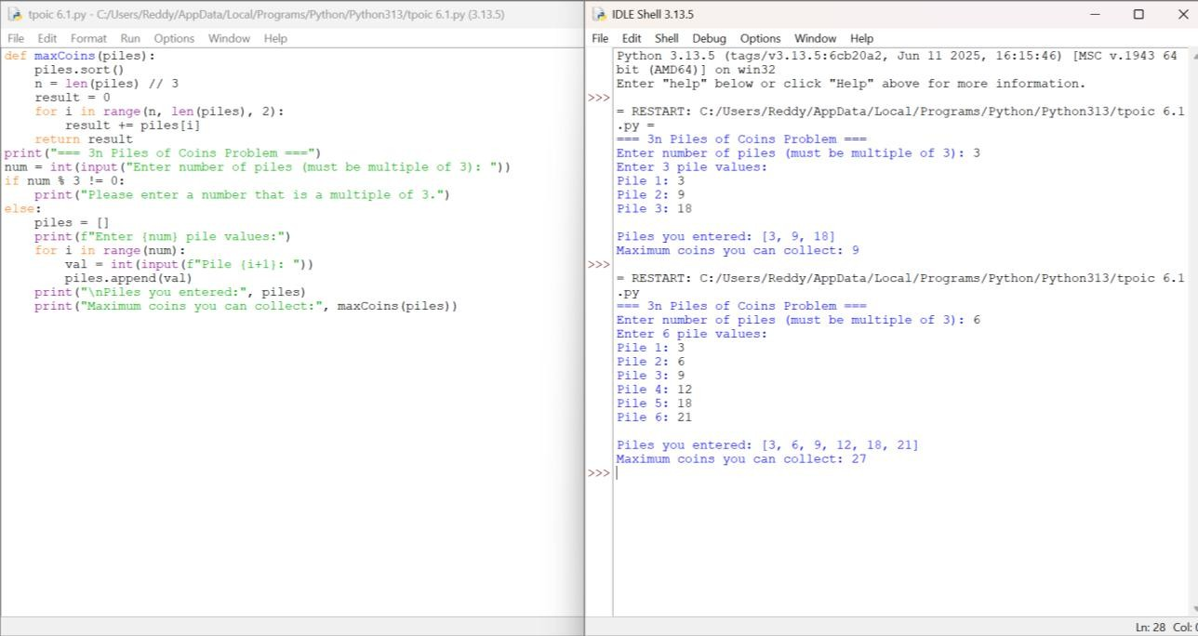

- Minimum of Coins

Aim: To write a Python program that finds the minimum number of coins

Algorithm:

  - Start the program.
  - Input the list of existing coin values and the target value.
  - Sort the list of coins in ascending order.
  - Traverse through the coin list:
  - Continue this process until reachable > target.
  - Print the value of added coins as the minimum number of coins to be added.
  - Stop the program.

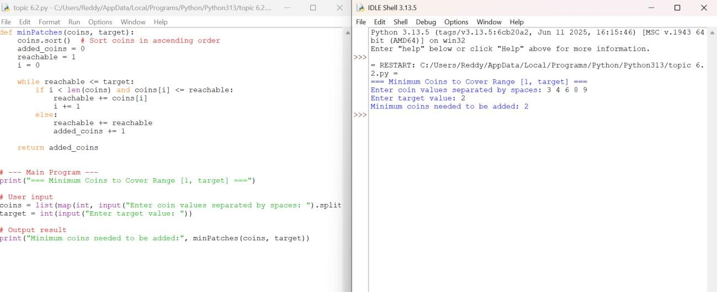
Input & Output: -

- Maximum Working time Aim:
To write a Python program that assigns n jobs among k each job is assigned to exactly one worker.

Algorithm:

  - Start the program.
  - Input the list of job times and the number of workers (k).
  - Define a helper function.
  - Use Binary Search on the answer.
  - For each mid-value between low and high:

  - Stop the program.

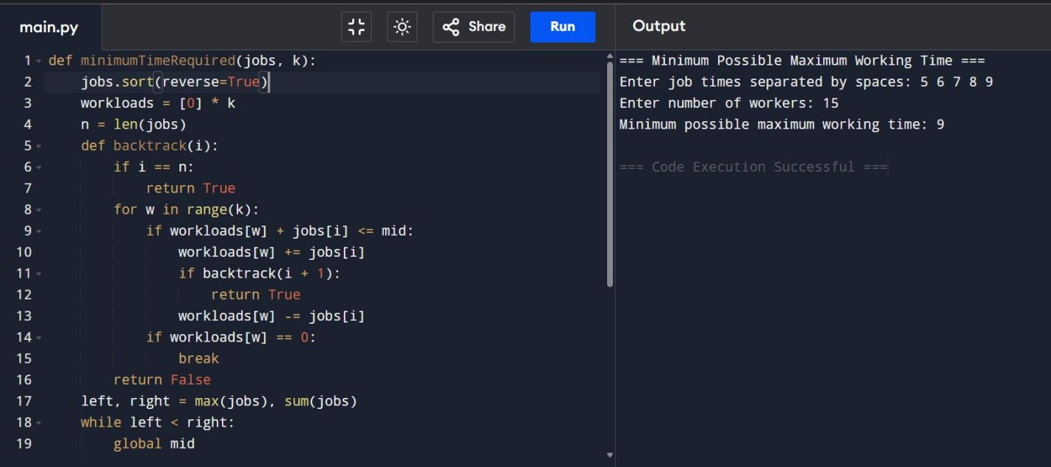
Input & Output: -

- Maximum Profit
Aim: To find the maximum profit subset of jobs such that no two jobs overlap.

Algorithm

  - Start the program.
  - Input arrays start Time, end Time, and profit.
  - Combine jobs into tuples and sort by end Time.
  - Initialize a DP array and an end times list.
  - Stop the program.

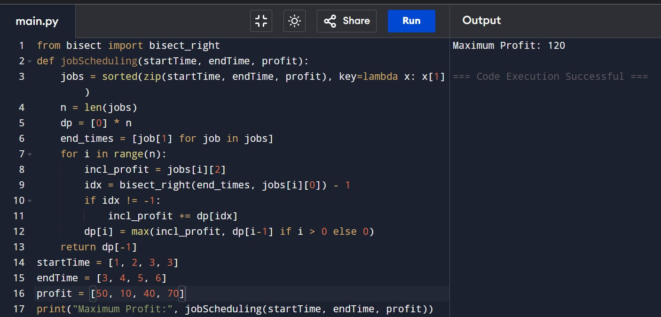
Shortest Path
Aim: To find the shortest path from a given source vertex to all other vertices in a weighted graph represented by an adjacency matrix using Dijkstra's Algorithm.

  - Start the program.
  - Input the adjacency matrix graph and the source vertex.
  - Initialize distance array with infinity for all vertices, except the source vertex which is 0.
  - Initialize a visited array to keep track of visited vertices.
  - Print the distance array.
  - Stop the program.

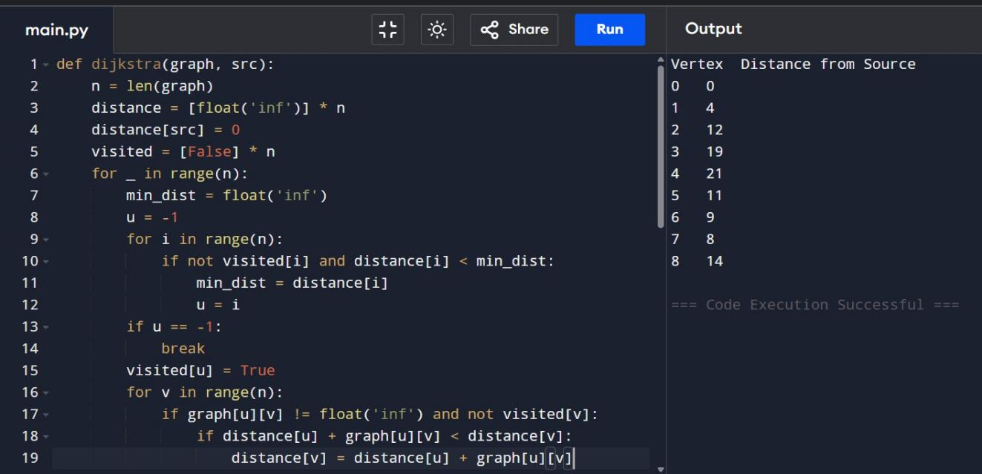

Shortest Path (vertex to target)

Aim: To find the shortest path from a given source vertex to a target vertex in a weighted graph represented as an edge list using Dijkstra's Algorithm.

Algorithm:

  - Start the program.
  - Input the edge list, number of vertices, source vertex src, and target vertex tgt.
  - Convert the edge list into an adjacency list for efficient lookup.
  - Initialize distance array with infinity for all vertices, except the source vertex which is 0.
  - Use a priority queue (min-heap) to select the vertex with the minimum distance at each step while the priority queue is not emp.

